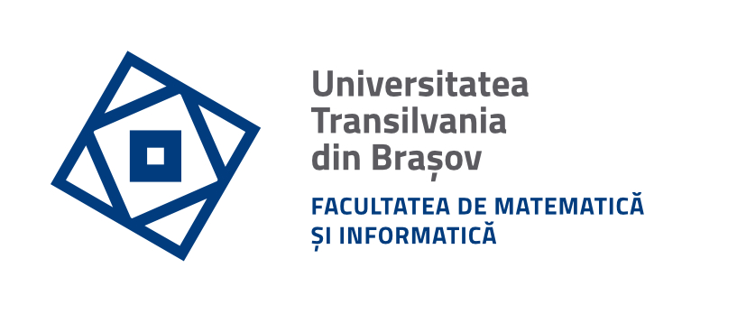

Programul de studii:
Informatica

Lucrare de licență
WhereWeFishin – Fishing Experience Discovery Platform Enchanced by AI

Autor: | Tatu Denis-Dimitrie
Coordonator ştiințific: | Lect. Dr. Spridon Delia

Braşov, 2026

